Press RELEASE
Solo Exhibition "Linger" by Vilnius Academy of Arts Professor Marija Marcelionytė-Paliukė to Open in New York
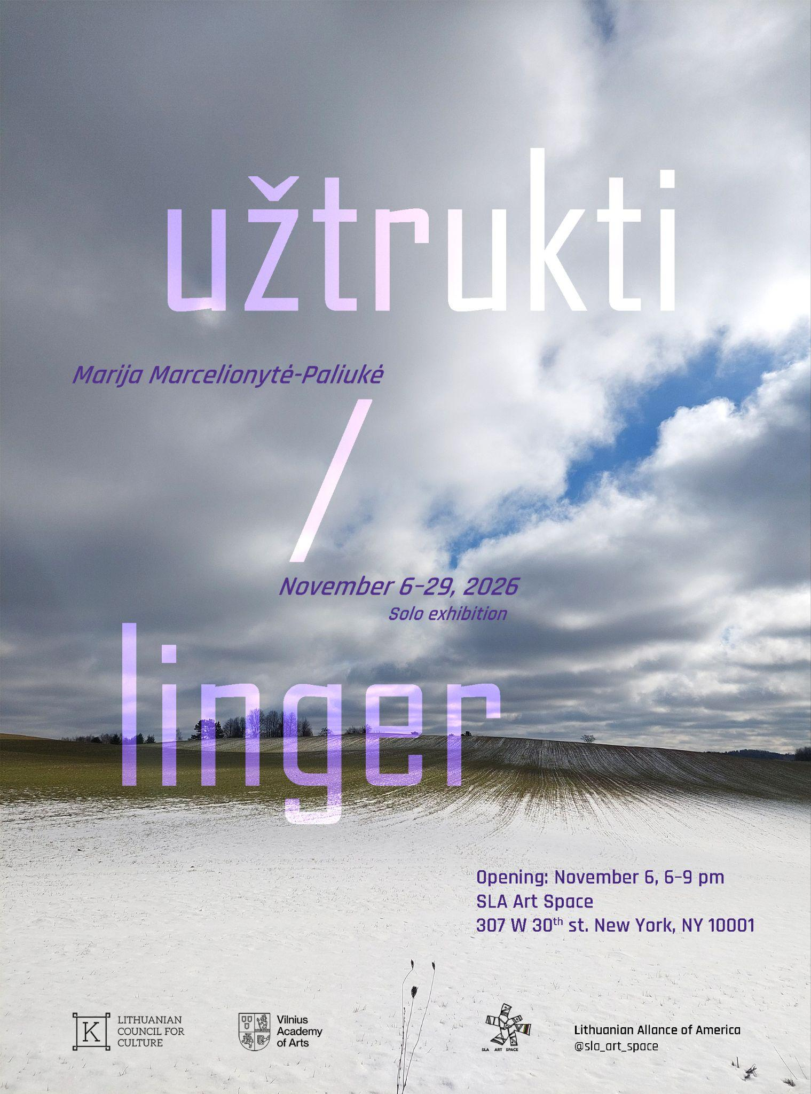
November 6, 2026, at 6:00 PM — SLA Art Space in New York (USA) will host the opening of "Linger", a solo exhibition by artist and Vilnius Academy of Arts Graphic Art Department Professor Marija Marcelionytė-Paliukė.

This exhibition marks the artist’s 27th solo show and a symbolic, magical return to New York after nine years. Nine years ago, she eagerly visited exhibitions here, explored the city she had known only through films for years, and collected stories. Today, the artist from Lithuania returns to the rhythm of the metropolis in an entirely different way: not as an observer, but as a creator bringing her personal exhibition to an international space.

The very title of the exhibition, "Linger", encompasses much more than simply staying in a space longer. In a world that rushes past and constantly navigates crises, the exhibition invites visitors to pause and experience a slower presence—that deep process where nothing can be accelerated: it takes time to return, it takes time to forgive and be forgiven, it takes time to understand, it takes time to create a work of art, or to love.

Living and creating outside of Vilnius, on the banks of the river, the artist is convinced that the deepest bonds with another person can be built through completely every day, simple things. Out of these grow much larger stories, capable of resonating with any gallery visitor, no matter where in the world they live. The exhibition presents recent works born from the artist’s personal experiences, taking the form of drawings, graphic prints, objects, audio and video recordings, and artist books.
"I think about what and how I could tell a story so that it would be interesting and meaningful to someone who knows nothing about me—and doesn't have to. I realized, or perhaps more accurately felt: I must try to create a space where one would want to linger. And you linger only when you feel expected, heard, and understood," shares Marija Marcelionytė-Paliukė.

The exhibition's display of personal histories and attentive environmental observation serves as a gentle catalyst for the viewer to recognize and share their own. Among the featured works is "Vendace" (Seliava)—a tiny fish tattooed intuitively on the artist’s arm nine years ago in North Carolina and now immortalized in polaroids; "Testimonies"—drawings transformed into unique graphic prints; "Entangled"—a three-dimensional textile object incorporating several kilometers of fishing line; and "Pareidolia"—a convergence of drawings and a poem read by the poet.

About the Artist: Marija Marcelionytė-Paliukė (b. 1977, Vilnius) is a professor in the Graphic Art Department at the Vilnius Academy of Arts (VAA), where she graduated in 2001, has taught since 2007, and has curated the VAA gallery "5 Malūnai" since 2018. The artist has held 26 solo exhibitions and participated in numerous group exhibitions in Lithuania and abroad. Her works are held in the collections of the Lithuanian National Museum of Art, the Jyväskylä Art Museum (Finland), the Lithuanian Museum of Currency, and in private collections. In 2023, she was awarded the Lithuanian Government Culture and Art Prize.

Visitor and Media Information:
- Venue: SLA Art Space, 307 W 30th St, New York, NY 10001, USA
- Dates: November 5–29, 2026
- Opening Reception: Wednesday, November 5, 6:00 PM – 9:00 PM
- More Information: https://tinyurl.com/2p9wewyn
- Social Media: Instagram @marija.marcelionyte, @5malunai; Facebook @Marija Marcelionyte
Organizers and Sponsors: The exhibition is funded by a 4-month individual grant from the Lithuanian Council for Culture. The exhibition and visit to New York are partially supported by: The Lithuanian Alliance of America, SLA Art Space, the Vilnius Academy of Arts Art and Science Project Fund, and the VAA Printmaking Department.

Media Contacts / Image Requests:
Francine Rogers
Email: francinernyc@gmail.com
Marija Marcelionytė-Paliukė
Email: marija.marcelionyte@gmail.com

